Josh Brown

Dr. Duan

Algorithms

4/21/21

Buchtel pgm’s

First, is the image of Buchtel after 50x20 seams removed:

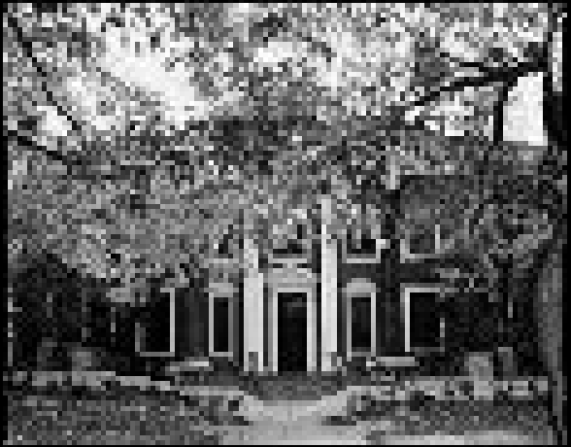

Next, Buchtel after 100x0 seams removed:

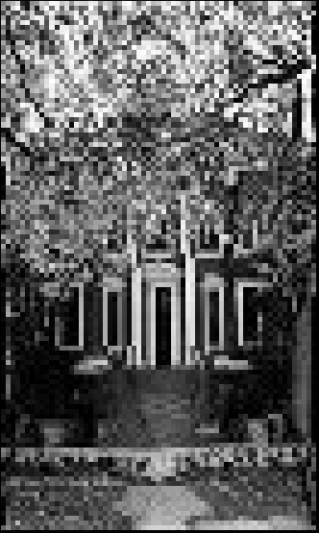

Both are zoomed at about 500%.